**Information Package**



**ASAA 4A Boys/Girls**

**Basketball**

**Provincial Championships**

Edmonton, Alberta

March 14 – 16, 2019

**Hosted by Jasper Place High School**

**Home Of The Rebels**

 

**Locations**: Jasper Place High School (JPHS) 8950-163 Street NW, Edmonton, AB

Harry Ainlay High School (HA) 4350-111 Street, Edmonton, AB

Paul Kane High School (PK) 12 Cunningham Rd, St Albert, AB

Salisbury Composite High School (SAL) 20 Festival Way, Sherwood Park, AB

St Francis Xavier High School (STFX) 9250-163 Street, NW, Edmonton, AB

St Albert Catholic High School (SACHS) 33 Malmo Ave, St Albert, AB

First round game time and location will be finalized once the final seedings are set. All Edmonton zone teams will play their First Round game in their home gyms. Once those games are set the rest will be filled in.

Presentation-games for both genders will be played at Jasper Place High School

**Tournament Contacts:**

Matt Burrows – Tournament Chair

[Matt.burrows@epsb.ca](mailto:Matt.burrows@epsb.ca)

780-298-0280

Mike Wilkie – Tournament Chair

[Mike.wilkie@epsb.ca](mailto:Mike.wilkie@epsb.ca)

780-970-0416

Donovan Wright – Video – Technology (streaming)

[Donovan.wright@epsb.ca](mailto:Donovan.wright@epsb.ca)

Grievance Committee

Eric Munoz – [Eric.Munoz@epsb.ca](mailto:Eric.Munoz@epsb.ca)

Rob Ennis – [Rob.Ennis@epsb.ca](mailto:Rob.Ennis@epsb.ca)

Dusty Freimark – [Dusty.Freimark@epsb.ca](mailto:Dusty.Freimark@epsb.ca)

**Website Address:**

<http://www.asaa.ca/championships/site/2019-4a-boys-and-girls-basketball>

**Host School Website:**

Jasper Place High School: <http://jasperplace.epsb.ca/>

Jasper Place Athletics: <http://rebelathletics.ca>

Tournament Schedule

The tournament draw will be posted on the host website

All girls teams will be playing their first round game on Thursday at 9:00am/11:00am – at Jasper Place High School and various locations throughout the city.

All boys teams will be playing their first round game on Thursday at 9:00/11:00am – at Jasper Place and various locations throughout the city.

Second round games on the championship side of the bracket will also be played later on Thursday at Jasper Place High School and Harry Ainlay High School.

All games on Friday and Saturday will be played at Jasper Place High School

**Tournament at a Glance**

**Monday, March 11th**

Registration Deadline (host website online) 12:00 pm

Banquet Ticket Deadline 12:00 pm

**Wednesday, March 13th**

Practice Times (1 hour time slots) 10:30 am – 5:30 pm

Team Pictures (first come, first serve basis) 12:00 pm – 6:30 pm

Banquet (Jasper Place High School) 7:00 pm – 9:00 pm

Coaches/Captains Meeting – Jasper Place 9:15 pm

**Thursday, March 14th**

Games Begin 9:00 am

**Friday, March 15th**

Games Begin 10:00 am

Semi-Finals 6:00 pm & 8:00 pm

**Saturday, March 16th**

Games Begin 10:00 am

Finals 6:00 pm & 8:00 pm

**Note:** First round games are spread out around the city

2nd round games are played at Jasper Place High School and Harry Ainlay High School

All Friday and Saturday games are played at Jasper Place High School

**Results:**

Results will be posted on the host website under “results” as well as at Jasper Place High School

**Registration/Fees:**

Tournament fees for the 4A Championships have been established by the ASAA at **$530/team**. This fee is based solely on ABOA costs. Teams will register for the tournament through the official host website. Please pay via Cheque or over the phone with credit card:

Please Make all Cheques Payable to:

**Jasper Place High School**

**8950-163 Street NW**

**Edmonton, AB**

**T5R 2P2**

Over The Phone:

**Call between the hours of 9:00am and 4:00pm Monday-Friday:**

**Call: 780-408-9000**

**Ask for the accounting office (Kim Eastman, Della Kazakoff, and/or Barbara Trimm will be able to process payment).**

When completing the online registration, the following information must also be provided: how many tournament banquet tickets are required for your team (Banquet tickets are $25/person. A maximum of 18 tickets are available to each team).

Team registration must be completed by Monday, March 11th at 12:00 noon.

Team fees must be paid prior to the banquet on Wednesday, March 13th.

**Banquet/Official Opening:**

The official opening of the tournament will be held in conjunction with the banquet on Wednesday, March 13th at 7:00pm – 9:00pm at Jasper Place High School in the Cafeteria. Attendance at the banquet/opening ceremonies is compulsory for all team members and coaches. Teams must wear attire that identifies them as a team.

Tickets are $25/person with a maximum of 18 tickets allowed per team. Tickets must be paid for a time of registration.

The banquet will include opening comments by ASAA executive members, words of inspiration via a guest speaker (TBA), and of course fed a full pasta meal.

**Pay it Forward Loonie Fee:**

There will be a “Pay It Forward Loonie Fee” assessed to all participants at provincials. This fee will be added to all provincial registration froms on the tournament website.

The Pay It Forward Loonie Fee – states that “each provincial championship will charge an additional $1 for each participating student and remit those funds to the ASAA office after the championship. Those funds will be directed to the ASAA scholarship fund to recognize student athletes who give back to their school and communities by either coaching or officiating in school or community sport.”

**Photos:**

All teams are expected to get team photos done Wednesday, March 13th. Photos will take place at Jasper Place High School (room 188) on a first come, first serve basis starting at noon (12:00 pm – 6:15 pm). If you are practicing at Jasper Place please come prior to or immediately following your practice.

Teams are requested to appear for photos with consistency of team gear. Player numbers **must** be visible in the photo.

We will not be doing individual photos, when the team is ready in their team gear the photo will only take 2-3 minutes.

**Warm-up Basketballs/Practice Sessions:**

All teams are required to provide their own basketball for practice/warm-up.

Dunking **will be** permitted in warm-up.

For visiting teams, practice times will be accommodated in one-hour blocks for Wednesday, March 13th, beginning at 10:30 am. Times will be allocated based on your zone and the distance you travel to get here. Teams may begin booking practice times online on Monday March 16th at 9:00am.

There will be a link to the online form on the website at that time.

**Coaches/Captains Meetings:**

These will be held at Jasper Place High School the evening of Wednesday, March 13th @ 9:15pm. All teams must have a representative present.

Coaches Meeting in the Millenium room

We will have signage in the hallways to direct coaches to the Millenium room

Captains Meeting in the teachers dining room

We will have signage in the hallways to direct captains to the teachers dining room.

**Webcasts:**

There will be webcast coverage for almost all games held at Jasper Place over the 3 day event:

Links for the webcasts will be broadcast through the ASAA YouTube channel for free.

**Gate Admission:**

*Please note: Passes gain the holder access to 4A Provincial Events ONLY, and acceptable forms of payment are **CASH ONLY**.

Adult Tournament Pass: $25.00

Student Pass $15.00

Adult Day Entry: $10.00

Student Entry: $5.00 (with Jr/Sr High School ID card)

Children Under 10: Free

Programs $5

**First Aid:**

Teams must provide their own medical supplies and plan to do their own taping. We will have a trainer’s room set up at Jasper Place High School in the Fitness Center (there will be signage in the hallways to direct people to the fitness center). Ice will be available upon request. Tournament Organizing Committee members will be available to assist you in accessing further medical attention if required.

**Hospitality/Concession:**

Jasper Place High School will operate a concession that will be **cash only**.

A Hospitality room will be provided by the Organizing Committee at Jasper Place High School. We ask cooperation in ensuing that these rooms be utilized by, adults-only – coaches, officials, and organizers. They are intended as an informal and friendly respites for participants and we request that criticisms/complaints (if any) be aired in more private areas.

**Tournament Souvenirs:**

Clothing sales will take place at Jasper Place High School and will be provided while quantities last. Elite Promotional Marketing is our official clothing sponsor and has provided us with the clothing for this event. The price range for the clothing is TBA. Cash will be the only method of payment accepted.

Clothing Sales hours of operation:

Thursday March 14 – 10:00 am – 1:00 pm, 5:00pm – 8:30pm

Friday March 15 – 10:00 am – 4:00 pm

Saturday March 16 – 10:00 am – 4:00 pm

**Awards Presentations:**

All “presentation games” will be held at Jasper Place High School and awards will be presented immediately following. These include Championship, Finalists, 3rd Place, 4th Place, and Consolation Championship. In accord with ASAA, Team Sportsmanship Awards will be presented by the ASAA to the recipient school at a time shortly after the competition.

**Sportsmanship:**

Consistent with ASAA values, a strong emphasis on and recognition of sportsmanship in both individual and teams will be highlighted. The Sportsmanship Committee will award individual pins in recognition of sportsmanship-like actions through the tournament, and will forward recommendation for the Team Award to the ASAA for later presentation.

The Sportsmanship Committee will be comprised of members of the Organizing Committee as well as a representative voice from the ABOA.

**Discipline and Misconduct:**

Breaches of the ASAA Code of Ethics are treated seriously and, as hosts, we are required to immediately report to the ASAA office any breaches that come to our attention. A portion of the ASAA Code of Ethics states “Any conduct, including, but not limited to ejections, fighting, drugs and alcohol use, that results in dishonor to the athlete, the team, the school or the ASAA will not be tolerated.” (pg. 29)

Coaches and/or athletes who have been ejected from a game will be required to leave the school premises for the duration of that match.

**Grievance/Discipline Committee:**

A Grievance/Discipline Committee will be in place to review any and all concerns that may occur. These will include appeals of application of ASAA policy (e.g. automatic game suspension for ejection of an athlete or coach), as well as tournament concerns. This Committee will be comprised of two members of the host committee.

Please reference the ASAA handbook.

**Code of Ethics/Sportsmanship:**

We remind all about the standards of behavior and performance for which the ASAA stands – applying the team’s members as well as supporters. Fair play and sportsmanship of team members are expectations of the ASAA and the Organizing Committee, and the responsibility of coaches. A reminder that artificial noisemakers are not allowed at ASAA events. While hosts will monitor and address unacceptable spectator behavior, we will – if necessary – call on team delegates to assist with their fans.

A reminder that a coach or player that is disqualified will receive a one game suspension. If it is the teacher sponsor that is disqualified, and no other teacher sponsor is available for that team, the tea will not be allowed to participate in their following game.

On behalf of Jasper Place High School, we welcome all participants to Edmonton. We hope that we will provide an enjoyable and successful event for all and that participants will leave with positive feelings about the conclusion to the 2018-2019 basketball season.

**Parking:**

During school hours (Wednesday, Thursday and Friday 9:00 am – 3:20 pm) teams (buses included) and spectators can park on the south side of the school in the student parking lot. Parking is also available to the south and east of the school in the residential areas surrounding the school.

After school hours teams (buses included) and spectators and park on the north, south, and east sides of the school in any school. Parking is also available to the south and east of the school in the residential areas surrounding the school.

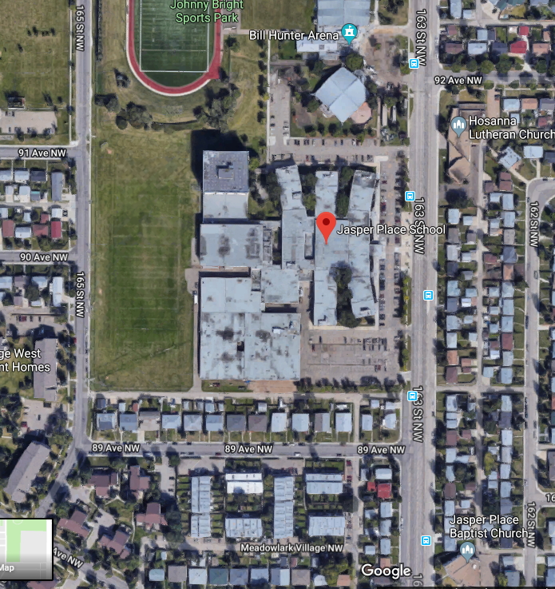

**Accommodation Information:**

**Double Tree by Hilton West Edmonton**

16615 – 109 Avenue NW

Edmonton, AB

T5P 4K8

(780) 484-0821

Booking: 4A Basketball Provincials

Email Contact: SPowley@silverbirchhotels.com

Direct Line: 780-930-4020

**Sandman Hotel Edmonton West**

17635 Stony Plain Road

Edmonton, AB

T5S 1E3  
(780) 483-1385

Group Booking Code: 476373

**School Map**:

